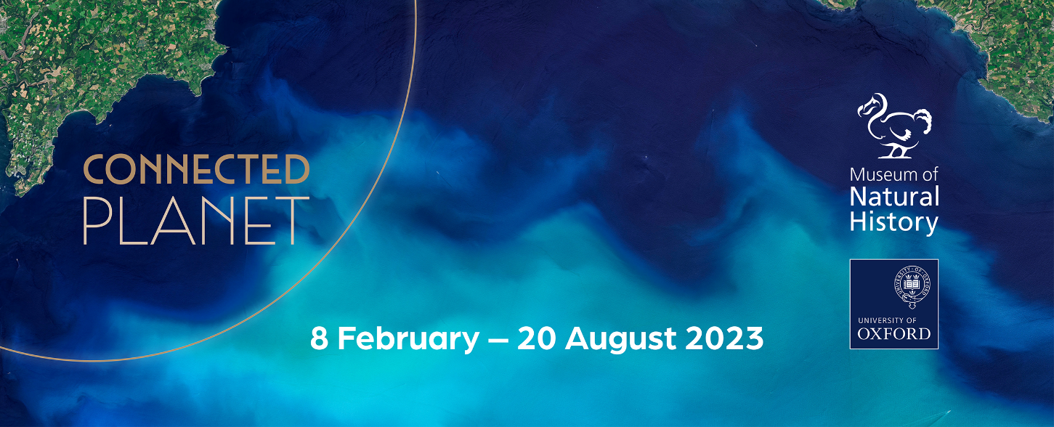

A journey through water, land, and air reveals the astonishing interactions between life and Earth

Connected Planet – Oxford University Museum of Natural History
Open: 8 February – 20 August 2023

An inspiring new exhibition at Oxford University Museum of Natural History about the incredible ways that life and Earth have endlessly shaped one another.
Connected Planet tells a story of a world in constant motion: from the daily migrations by trillions of sea creatures, to a hidden world of communication beneath our feet. The exhibition draws on Museum researcher Dr Elsa Panciroli’s book Earth: A Biography of Life (Quercus, 2022) and is the latest exhibition in the Museum’s award-winning exhibition series on science and society.
Connected Planet shows how Earth and life exist in equilibrium, how over the millennia its biological processes have become an integral part of the natural world and how this balance is upset and re-established over time. The exhibition explores:
- The largest daily migration of animals on Earth: the nightly movement of trillions of animals, from tiny crustaceans to the largest vertebrates on Earth, up to the ocean surface to feed on Carbon-rich phytoplankton. The animals return to the depths as the sun rises, taking with them the solar energy and the atmospheric carbon, which are deposited on the ocean floor as soft, grey marine snow.
- The ecosystem-building power of the first plants to colonise the rocky land. These plant pioneers created the first soils and built themselves, and millions of other organisms, an enduring home: a process that continues today and gives us our lush green land cover.
- Cyclical catastrophes and recoveries that affect the natural and human world alike, contrasting the impact of the 2010 Eyjafjallajökull volcanic eruptions in Iceland, which grounded airplanes across Europe, with the end-Permian mass extinction 252 million years ago that wiped out 85 per cent of species on the planet.

Specimens from the Museum’s collections are displayed with loans from Cambridge University Museum of Zoology and the Sedgwick Museum of Earth Sciences to bring these dramatic processes to life. Exhibit highlights include:
- jagged fragments of volcanic rock blasted from the vent of an Icelandic volcano;
- a beautiful tropical frog and sea snake affected by the El Nino and La Nina weather systems;
- an exceptionally preserved sea lily, one of the few survivors of the largest mass extinction in history; and
- ceramic models of phytoplankton enlarged one hundred-fold to show their stunningly sculptural shells. Visitors may even catch a glimpse of an industrious earthworm at work in the exhibition wormery.
A digital interactive developed in collaboration with researchers at Victoria University in Canada allows visitors to explore biodiverse kelp forests from coastlines around the world. Other digital displays feature University of Oxford researchers answering questions on their research into the connections between Earth and life. Through these Q&As, visitors will learn how fungi have terraformed our world, the critical role of phytoplankton in sustaining life, and the impact of mass extinctions on the life that follows them.
Professor Paul Smith, Director of Oxford University Museum of Natural History, says:
“There has never been a more important time for understanding the intricate interconnections between Earth’s biology and geology. Connected Planet examines the delicate balance of these systems, showing how they frequently depend on each other. On the one hand, Earth processes can shape the evolution of organisms and the health of ecosystems but, equally, evolution can change landscapes in very unexpected ways. And disruptions on either side can lead to dramatic consequences.”
Museum researcher and author of Earth: A Biography of Life, Dr Elsa Panciroli, says:
“Earth is the only planet we know of that is so wondrously complex and filled with incredible organisms. The way in which living things are interlinked with the planet through deep time is just mind blowing. Change one, and the other responds. When the first mossy plants colonised land over 400 million years ago, they created soils and altered the course of entire river systems. This remodelled our landscape, changing how it erodes, which in turn affected the chemistry of the sea and sky – even triggering an ice age!
“Small changes continue to create ripples from top to bottom in ecosystems around the world. In Connected Planet we look at how scientists study these ripples in the past, as well as in the fragile present. This knowledge is vital to help us create a better future.”
This exhibition invites us to take a closer look at the strands connecting all of nature, including us. As the natural world is increasingly affected by human activity, these relationships remind us that there is still a whole world worth saving.
Connected Planet is free to visit. For more information, visit oumnh.ox.ac.uk/connected-planet, follow @morethanadodo on social media, and read the Museum’s blog at morethanadodo.com.

NOTES FOR EDITORS
About Oxford University Museum of Natural History
Founded in 1860 as the centre for scientific study at the University of Oxford, the Museum now holds the University’s internationally significant collections of entomological, geological and zoological specimens. Housed in a stunning Pre-Raphaelite-inspired example of neo-Gothic architecture, its growing collections underpin a broad programme of natural environment research, teaching and public engagement. The Museum is currently transforming its permanent displays through the Life, As We Know It masterplan project. ‘Meat the Future’, the previous Contemporary Science and Society exhibition, won the 2022 ‘Partnership of the Year’ Museum + Heritage Award.

Images
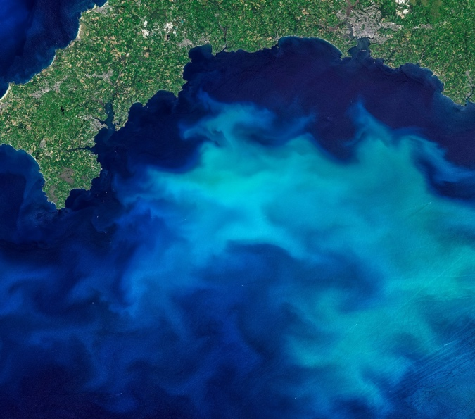 | Phytoplankton bloom off the South Coast of the UK. Blooms draw tons of carbon from the atmosphere down into the oceans as the tiny organisms are eaten or die and float down into the depths as marine snow.  Credit: Adobe stock
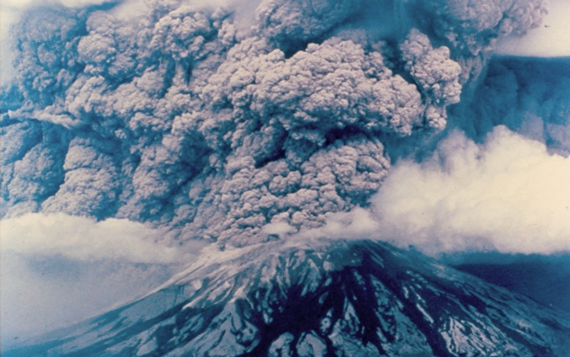 | The 1980 eruption of Mount St. Helens devastated the surrounding landscape, allowing researchers to study short-term and long-term ecological responses, and track the recovery of damaged ecosystems.  Credit: DNR, CC BY-NC-ND 2.0
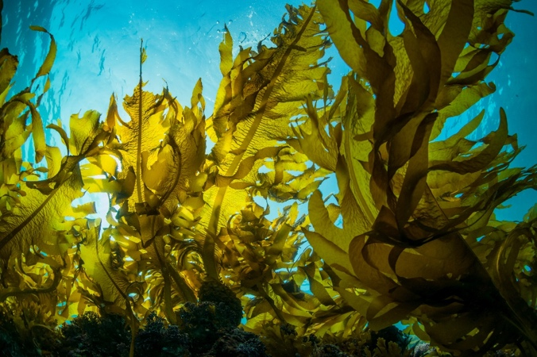 | Kelp forest. These brown algae create ecosystems that are home to over 200 species of animals and play a part in absorbing carbon from the atmosphere.  Credit: Adobe stock
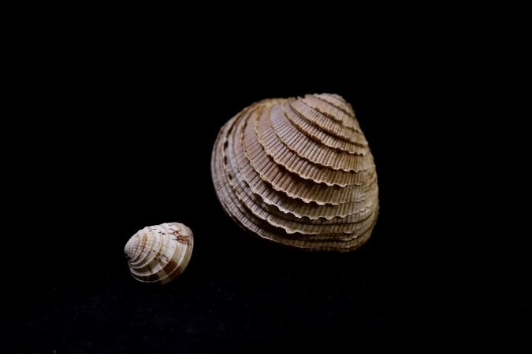 | Venus Clams from the Caribbean (L) and the Pacific (R) (Chione cancellata and Chione gnidia). Pacific Venus Clams grow larger than Caribbean species as cool Pacific waters provide more food. The origins of this difference lie in the formation of Panama, the separation of the Caribbean and Pacific waters and the deflection of the warm currents from the Atlantic.  Credit: Oxford University Museum of Natural History
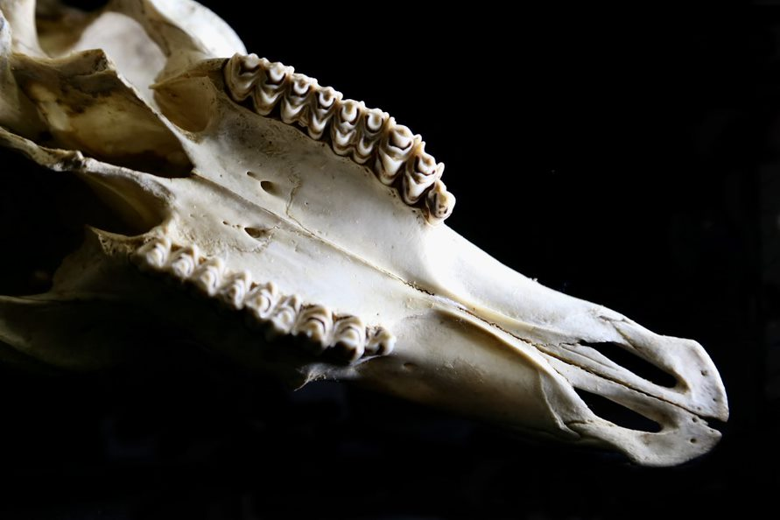 | Kob teeth (Kobus kob). Wide and ridged teeth are one of the adaptations that help Kobs to thrive as grassland grazers.  Credit: Oxford University Museum of Natural History
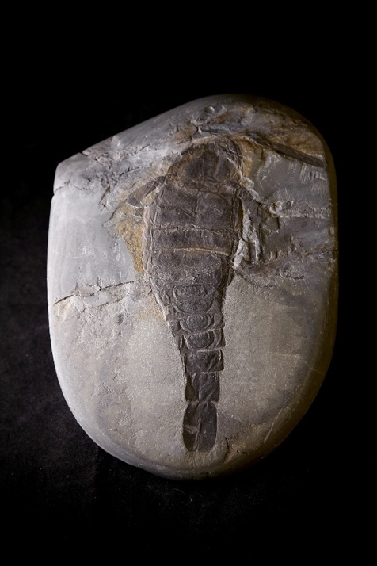 | Sea scorpion (Pterygotus bilobus). This marine predator, which could reach lengths of 2.5 meters, was one of the 85 per cent of species wiped out by the Permian extinction.  Credit: Oxford University Museum of Natural History
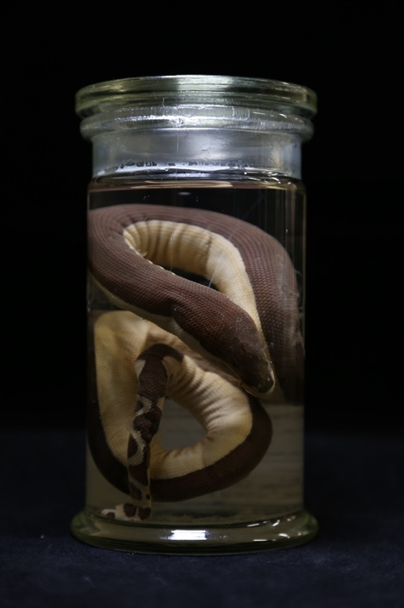 | Yellow-bellied Sea Snake (Pelamis platurus). An exotic, and highly venomous, visitor to Californian beaches as a result of warm sea temperatures attributed to El Niño.  Credit: Oxford University Museum of Natural History

