**STORY AND ASSETS EMBARGOED UNTIL MONDAY JULY 13TH 2020 AT 2000 LONDON TIME (GMT) / 1500 US EASTERN TIME / 0400 (+1DAY, TUESDAY 14TH) JAPAN STANDARD TIME. PROCEEDINGS OF THE NATIONAL ACADEMY OF SCIENCES OF THE UNITED STATES OF AMERICA.**

**Design of insect-inspired fans offers wide-ranging applications**

* **A new design method for highly compact deployable structures is based on the sophisticated folding of earwig wings**
* **The new earwig-inspired fan mimics the most compact wing folding found in insects, and will offer multiple applications, from daily use articles to aerospace engineering**
* **The study also opens up new explorations on the evolution of the earwig wings, enabling researchers to predict possible extinct forms**

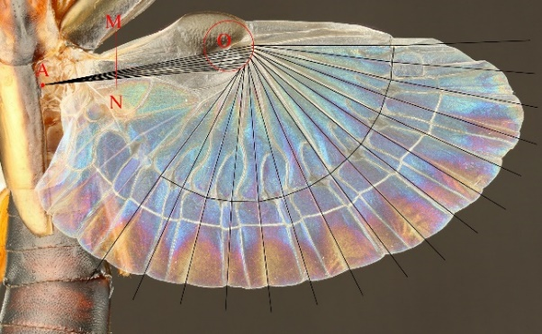A highly sophisticated folding mechanism employed by a group of insects for at least 280 million years is set to become available for a wide range of applications, thanks to a design method developed and tested through multidisciplinary research by engineers and palaeobiologists.

According to an article published in the *Proceedings of the National Academy of Sciences of the United States of America* today (<https://www.pnas.org/cgi/doi/10.1073/pnas.2005769117>)*, researchers have recreated 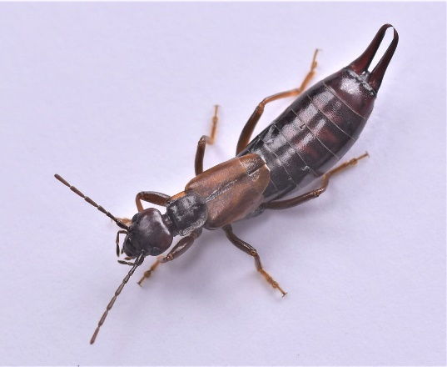the complex, highly compact folding mechanisms found in the wings of earwigs with an origami-inspired geometrical method, which has potential applications across different fields of engineering.

**Schematic for the new design method of the earwig-inspired fan, above shown projected onto the hind wing of an earwig (*Proreus simulans*). Credit: Kazuya Saito.**

The hind wings of earwigs fold automatically under small leathery forewings when the animal is not in flight, employing a specialised folding pattern that reduces surface area ten to 15 times or more depending on the species. This is the most compact wing folding found in insects and gives earwigs unparalleled ground mobility for a flying insect. With the wings protected and their abdomens fully flexible, earwigs are able to wriggle into the soil and other narrow spaces, as well as use their characteristic rear pincers.

**The earwig Forficula mikado with wings folded. Credit: Kazuya Saito.**

Despite the outstanding potential for engineering of the earwig wing and its unique properties, a method for designing their complex folding patterns had not been resolved, hindering practical applications.

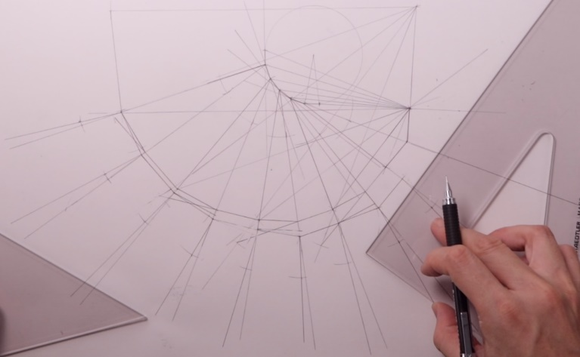“The method to design our earwig-inspired fan is based on the flat-foldability in the origami model, a mathematical theorem that explains how crease patterns may be folded to form a flat figure,” explains lead author Dr Kazuya Saito, an engineer from Kyushu University’s Faculty of Design who specialises in bioinspired deployable structures. “Our earwig fan can be designed using classic drawing techniques, but we have also developed and released software that can automatise the process depending on the application requirements.”

The geometrical requirements for the new design method were informed by tomographic imaging in folded earwig hind wings.

**Hand drawing of the earwig-inspired fan using the new geometrical method. Full process is provided in a video from the publication. Credit: Kazuya Saito.**

Researchers predict that their earwig-inspired fan will see multiple applications for folding structures, of variable sizes and materials, into highly compact shapes that can be efficiently transported and deployed. These may include daily-use 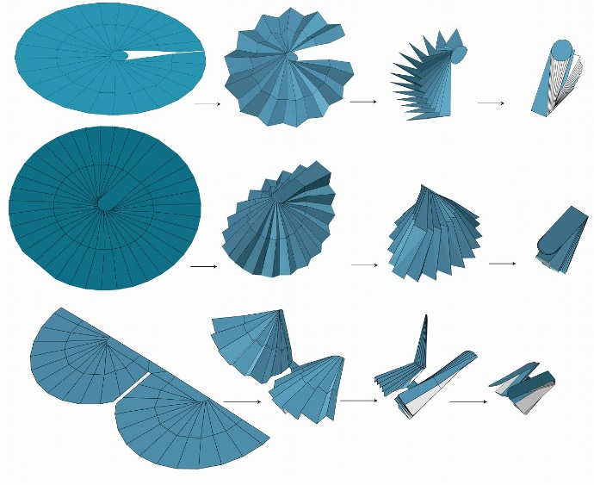articles such as fans or umbrellas, as well as multiple structures for use in architecture, mechanical engineering, and the aerospace industry, such as drone wings, antennae reflectors, or energy-absorbing panels.

On the other hand, the research provides new insights into evolutionary biology, as the new design method can also recreate the wing-folding mechanism of 280 million-year-old earwig relatives.

**Examples of customised earwig-inspired fans made using the new design software. Above: two models of earwig fans for use in deployable structures such as antenna reflectors or umbrellas. Below: deployable wings for a micro air vehicle. Note the high compactness of the fans when fully folded. Credit: Kazuya Saito.**

“The wings of modern earwigs show little variation across their approximately 2,000 living species, with shape and folding patterns remaining remarkably stable through evolution because of their specialised function,” says Dr Ricardo Pérez-de la Fuente, an insect palaeobiologist from Oxford University Museum of Natural History and co-author of the work. “However, a group of long-extinct insects – the protelytropterans – possessed fan-like wings similar to those of earwigs, but different enough to test the consistency of the new design method. Our work shows how palaeontology can be of interest for practical applications.”

The new method defines the geometrical constraints for the fan-like wings of both earwigs and their deep-time protelytropteran relatives to remain functional. This allowed the researchers to project extinct, hypothetical intermediate forms between the two groups, shedding light on possible evolutionary pathways that could have led to the sophisticated wings of modern earwigs.

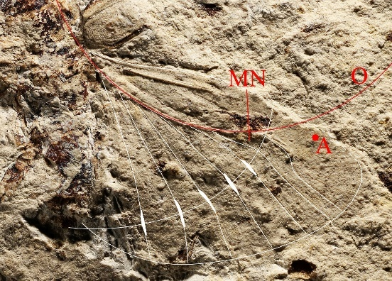This research represents a multidisciplinary effort between engineers and evolutionary biologists from Japan and the United Kingdom. Specimens from Oxford University Museum of Natural History and the Museum of Comparative Zoology (Harvard University) provided data to build and test the geometrical method, highlighting the value that natural history collections harbour, including for state-of-the-art applications.

“Nature has consistently been an everlasting source of inspiration,” says Prof Zhong You, from Oxford University’s Department of Engineering Science and co-author of the work. “Bioinspired technologies keep offering some of the most efficient and sustainable ways to meet many of the challenges of the future.”

**Fossil hind wing from a protelytropteran insect with wing venation highlighted (above), and folding pattern of the same wing as obtained with new geometrical method (below). Extracted from publication and modified by authors; fossil image is ©President and Fellows of Harvard College.**

**

**Notes**

* (*) The paper “***Earwig fan designing: biomimetic and evolutionary biology applications***” is published as open access in the journal *Proceedings of the National Academy of Sciences of the United States of America* (=PNAS)*.* Direct link: <https://www.pnas.org/cgi/doi/10.1073/pnas.2005769117> (this link will be enabled after the publication date and time). For accessing the original article before the embargo lifts, refer to PNAS’ EurekAlert press note at <https://www.eurekalert.org/emb_releases/2020-07/potn-efs070820.php>
* Images used in the present release and additional media, including a promotion video and paper crafts based on the present research, can be accessed through the following link:

<https://storage.design.kyushu-u.ac.jp/public/109MAAJLT8oAKFQBLhBzkYgMd4ngSdmuNkgQnIfbaHus>

* The international team comprised researchers from Kyushu University, Fukuoka, Japan; Oxford University, Oxford, United Kingdom; JT Biohistory Research Hall, Osaka, Japan; The University of Tokyo, Tokyo, Japan; and Hokkaido University, Sapporo, Japan.

**For further information and images, please contact:**

Dr Kazuya Saito

Lecturer

Faculty of Design, Kyushu University

**k-saito@design.kyushu-u.ac.jp**

+81 092-553-4554

Dr Ricardo Pérez-de la Fuente    
Museum Research Fellow    
Oxford University Museum of Natural History    
[**ricardo.perez-de-lafuente@oum.ox.ac.uk**](mailto:ricardo.perez-de-lafuente@oum.ox.ac.uk)*Note: I am working from home due to the current health situation. If you would like us to speak, please email to schedule an online call. Thank you.*

**Web pages of showcased scientists**

Dr Kazuya Saito: <https://hyoka.ofc.kyushu-u.ac.jp/search/details/K007146/english.html>

Dr Ricardo Pérez-de la Fuente: <https://www.oumnh.ox.ac.uk/people/ricardo-perez-de-la-fuente>

Prof Zhong You: <https://eng.ox.ac.uk/people/zhong-you/>

**Notes to editors**

**About Kyushu University**

Founded in 1911, Kyushu University and its 12 undergraduate schools, 18 graduate schools, hospital, world-class research centres, and multiple campuses—including the largest in Japan—form a hub for a broad spectrum of innovative research and education on the southern Japanese island of Kyushu. The Faculty of Design, which began as the Kyushu Institute of Design in 1968 before merging with Kyushu University in 2013, engages in education and research related to design, as well as practical application of design, revolving around the concepts of "Art” and “Engineering."

[www.kyushu-u.ac.jp](http://www.kyushu-u.ac.jp/)

[www.design.kyushu-u.ac.jp/en](http://www.design.kyushu-u.ac.jp/en)

**About Oxford University Museum of Natural History**

Founded in 1860 as the centre for scientific study at the University of Oxford, the Museum of Natural History now holds the University’s internationally significant collections of entomological, geological and zoological specimens. Housed in a stunning Pre-Raphaelite-inspired example of neo-Gothic architecture, the Museum’s growing collections underpin a broad programme of natural environment research, teaching and public engagement.

[www.oumnh.ox.ac.uk](http://www.oum.ox.ac.uk/)

[www.morethanadodo.com](http://www.morethanadodo.com/)