For immediate release

Oxford vaccine pioneer comes face-to-face with 'our mortal enemy' in new display of coronavirus sculpture

Professor Sarah Gilbert, lead developer of the Oxford-AstraZeneca vaccine, to unveil sculpture of coronavirus particle at Oxford University Museum of Natural History

2020: The Sphere that Changed the World
18 May – 17 September 2021
Oxford University Museum of Natural History
https://oumnh.ox.ac.uk/angela-palmer-2020

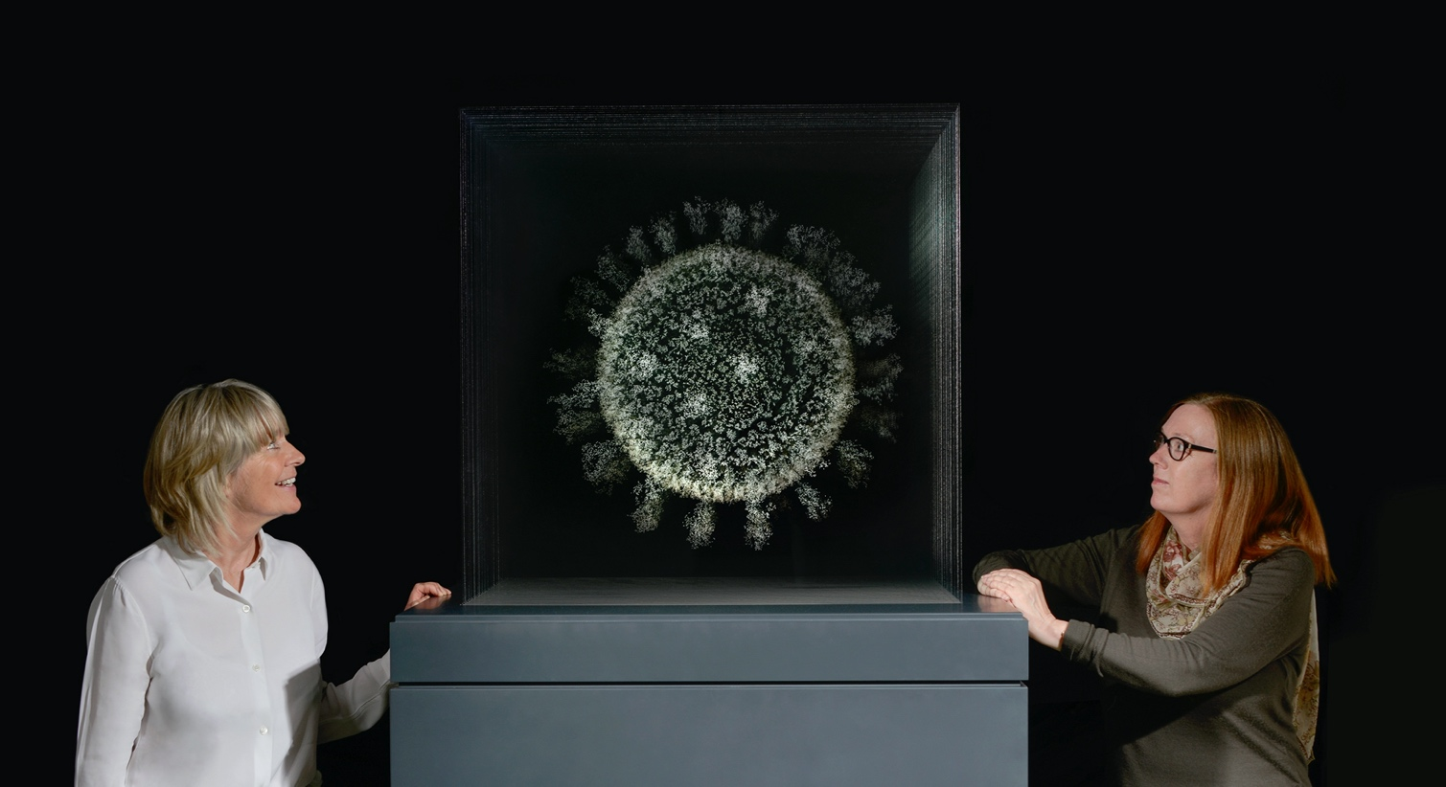
Artist Angela Palmer and Professor Sarah Gilbert with ‘2020: The Sphere that Changed the World’

14 May 2021 - The pioneer of the Oxford-AstraZeneca COVID-19 vaccine, Professor Sarah Gilbert, will unveil a sculpture of the original Wuhan coronavirus particle on a scale eight million times its size at Oxford University Museum of Natural History.
2020: The Sphere that Changed the World by Scottish artist Angela Palmer will be unveiled on Monday 17 May, at the re-opening of the museum, just two miles from the laboratories where Professor Gilbert and her team developed the vaccine, which is now protecting millions of lives. Dr Maheshi Ramasamy of the Oxford Vaccine Group and Lord Patten, Chancellor of Oxford University, will join Professor Gilbert at the launch. A second work by Palmer will also be unveiled: ‘The Spike’ (pictured below), a dramatically upscaled representation of the virus’ deadly protein spike which enables the particle sphere to invade the human cell.
2020: The Sphere that Changed the World is an eerie and ethereal rendering of the coronavirus: from the front of the sculpture you are confronted by the entire sphere, with its protein spikes emerging from the surface, but as you pass around, it disappears entirely from view, only to reappear again, echoing the elusive behaviour of the virus as it continues to spread around the world.
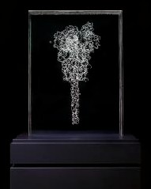
Professor Sarah Gilbert said: ‘Angela’s powerful and thought-provoking sculpture is a beautiful yet fragile representation of the virus that has become our mortal enemy. The separate image of the spike protein represents the weapon that we have used to fight back, using that part of the virus to make the vaccines to protect us all.’
2020: The Sphere that Changed the World is an experiential sculpture that Palmer hopes will offer us all an opportunity to reflect on the year our lives changed forever and to pay tribute to the groundbreaking collaborative work of scientists worldwide during the pandemic.
The artist, an Oxford University alumna, conceived the work as the pandemic began to grip the world last year. She began to focus on the physical structure of the particle itself as it spread across the world to devastating effect. Palmer said, ‘As an artist, my work focuses on stripping back the outer layer to expose what lies hidden beneath, and I grew determined to capture this particle – the ‘invisible enemy’ – and lay it bare.’
‘The Spike’, Palmer’s sculpture of the deadly protein spike
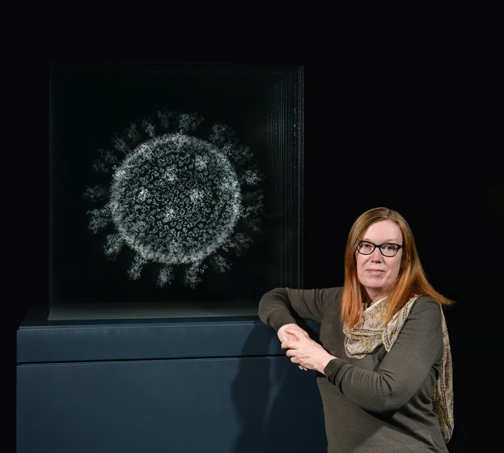
Palmer’s ambitious vision involved engraving details of the virus’s complex structure onto multiple sheets of glass to create a three-dimensional ‘drawing’ of the particle suspended in space. However, the magnitude of this task soon became clear when the artist realised the nanoscopic scale of the particle: a thousand times smaller than the width of a human hair.
Undeterred, she sought out experts from around the world and tracked down one of the world’s leading experts in molecular modelling of coronaviruses: Dmitry Korkin, associate professor of computer science and director of the bioinformatics and computational biology program at Worcester Polytechnic Institute in Worcester, Massachusetts. Professor Korkin explained that while he had managed to model the virus ‘spike’, the most deadly part of the particle’s armoury, he was only just beginning the gargantuan mission of mapping the whole virus sphere.
Professor Gilbert with ‘2020: The Sphere that Changed the World’
While Palmer worked on the first stage of her mission, engraving the protein spike with data supplied by Professor Korkin, the scientist and his team worked round the clock to map the whole particle sphere, or to be scientifically correct, the ellipsoid which, like the Earth, is slightly flattened at its poles. Professor Korkin worked in collaboration with Professor Siewert-Jan Marrink at the University of Groningen in the Netherlands, using one of the world's most powerful supercomputers at The Texas Advanced Computing Centre to model the sphere, armed with information from the genomic map of the original Wuhan virus.
Several months later, Professor Korkin forwarded the completed model consisting of around 60 million atoms to the artist. Palmer then faced the challenge of translating the vast and complex data set into a sequential series of accessible cross-sections to map the details. The artist spent many months of lockdown in her north London studio meticulously hand engraving 28 sheets of glass before stacking them together to form the entire sphere.
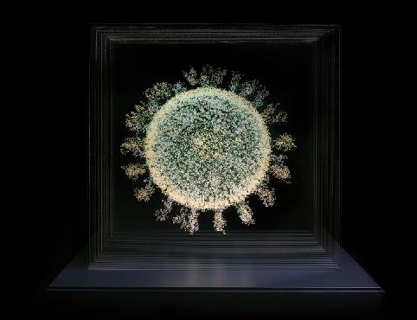
Palmer said: ‘When I saw the virus in its entirety for the first time, suspended in its glass chamber, I was taken aback by its beauty. It was totally unexpected. It seemed in direct contradiction to the nature of this menace which has terrorised us all and continues to do so. It was hauntingly beautiful, paradoxically so. I found it strangely transfixing and mesmerising: the invisible enemy, as we know it, was suddenly rendered tangible, trapped, while the whole of mankind is trapped by it.’
The front view of Palmer’s sculpture: ‘2020: The Sphere that Changed the World’
The artist believes the sculpture offers individuals an experiential opportunity to reflect on the year 2020 as a turning point in history: “The installation may prompt reflection and contemplation of loss – a loss that will, of course, be unique to each of us,’ said Palmer. ‘Laid bare, at eight million times its size, the particle may also offer empowerment and agency, seen suspended and imprisoned in glass, open to scrutiny and interrogation. The deadly and elusive entity is suddenly rendered solitary, isolated and vulnerable, unsettlingly mirroring the condition it has imposed, and continues to impose, on us ourselves.’
Professor Korkin said: ‘This will be the sculpture representing one of the darkest moments of modern human history that will stay with society for many generations. The sculpture represents one of the deadliest enemies of humankind and makes us realise how vulnerable and fragile, as glass, we, as humans, still are. But, I think it carries another powerful message — that we can understand, fight, and eventually conquer such an enemy with science.’
The presentation of 2020: The Sphere that Changed the World at Oxford University Museum of Natural History continues the museum’s commitment to showcasing work at the interface of art and science, as well as connecting with Oxford University’s groundbreaking work to produce the Oxford-AstraZeneca COVID-19 vaccine.
Professor Paul Smith, director of the Museum of Natural History, said: ‘We are tremendously pleased to be hosting the inaugural display of this beautiful, eerie and timely artwork. Angela Palmer’s Ghost Forest was installed on our lawn ten years ago, so it is a pleasure to work with her again to present a piece that truly embodies the power of art and science to move us emotionally and intellectually.’
The artist intends to create three spheres in total. This sphere on display at the Museum of Natural History has been acquired by the Science Museum Group as part of its COVID-19 Collecting Project, which aims to provide a permanent record of medical, scientific, cultural and personal responses to the pandemic.

- Ends -
Media enquiries: Suzanne de la Rosa, Head of Communications & Marketing, Oxford University Gardens, Libraries & Museums suzanne.delarosa@bodleian.ox.ac.uk 07525 227337
All images above by Andrew Smart of A.C.Cooper Ltd
Images & files, including a short film are available to download at: https://www.dropbox.com/sh/05xn7xis20qc9fx/AABKZfNWSCQnX7D9oFMKire2a?dl=0
Artist contact: angelaspalmer@gmail.com www.angelaspalmer.com

Notes
About the Artist, Angela Palmer
Angela Palmer has sculptures in the permanent collections of several major institutions worldwide, including her reconstruction of a 2,000-year-old Egyptian child mummy as a three-dimensional drawing on glass in the Ashmolean Museum, Oxford, and a sculpture representing an area of space using Nasa data for the Kepler mission which is in The Smithsonian Air and Space Museum, Washington. She has further sculptures in: The National Galleries of Scotland; the Wellcome Trust; The Royal College of Physicians; The Royal Papworth; and Oxford University. Sir John Leighton, director of The National Galleries Scotland, selected one of her works in his book 100 Masterpieces of the National Galleries of Scotland (‘Brain of the Artist.’)
The three-dimensional presentation of cross-sectional data is a technique the artist adapted while studying anatomy as a student at The Ruskin School of Drawing and Fine Art, Oxford University. Palmer was inspired by a laboratory model demonstrating the structure of penicillin exhibited in the History of Science Museum in Oxford, which was made in the 1940s by the Nobel laureate Dame Dorothy Hodgkin. She went on to create anatomical works derived from MRI and CT scans, which can be found on her website www.angelaspalmer.com
Palmer was previously a journalist whose career included the editorship of The Observer Magazine and Elle Magazine.
About Professor Sarah Gilbert
Sarah Gilbert is the Said Professor of Vaccinology in the Nuffield Department of Medicine at the University of Oxford. She completed her undergraduate studies at the University of East Anglia and her doctoral degree at the University of Hull. Following four years as a research scientist at the biopharmaceutical company Delta Biotechnology she joined Oxford University in 1994 and became part of the Jenner Institute (within NDM) when it was founded in 2005. Her chief research interest is the development of viral-vectored vaccines that work by inducing strong and protective T and B cell responses. She works on vaccines for many different emerging pathogens, including influenza, Nipah, MERS, Lassa, Crimean-Congo haemorrhagic fever, and in 2020, initiated the SARS-CoV-2 vaccine project. Working with colleagues in the Jenner Institute research labs, the Clinical Biomanufacturing Facility and Centre for Clinical Vaccinology and Tropical Medicine, all situated on the Old Road Campus in Oxford, she is able to take novel vaccines from design to clinical development, with a particular interest in the rapid transfer of vaccines into manufacturing and first in human trials. She is the Oxford Project Leader for ChAdOx1 nCoV-19, a vaccine against the novel coronavirus, SARS-CoV-2 which is now in use in many countries around the world.

About scientist Professor Dmitry Korkin
Professor Dmitry Korkin and his team at Worcester Polytechnic Institute in Worcester, Massachusetts, US in collaboration with Siewert-Jan Marrink, professor of molecular dynamics at the University of Groningen, Netherlands, created a molecular model of SARS-CoV-2 coronavirus that caused the COVID-19 pandemic using the genomic map of the coronavirus, made available by The National Centre for Biotechnology Information in the US.
The director of the university’s bioinformatics and computational biology program, who previously worked on the SARS coronavirus, used molecular modelling to reconstruct the major viral proteins which make up the deadly COVID-19 particle, and their interaction with human proteins. He made his findings available to experimental scientists worldwide, offering researchers a window into the similarities and differences between SARS-CoV-2 and previous coronaviruses such as SARS-CoV. Through his modelling, Professor Korkin was able to pinpoint functionally important areas of the proteins that have not changed throughout the course of evolution and can therefore serve as important new targets for drugs that will fight this and the future coronaviruses.
Professor Korkin hopes his pioneering findings can help in both treatment and in establishing how the virus spreads. He said: ‘This is one of the first examples of how data-driven integrative science can quickly respond to this challenge, making us much more prepared for the next pandemic.’

To speak with Dmitry Korkin, contact: Colleen Wamback, Director of Public Relations
Worcester Polytechnic Institute Worcester, Massachusetts USA cbwamback@wpi.edu 508-688-4858

About Oxford University Museum of Natural History
Founded in 1860 as the centre for scientific study at the University of Oxford, the Museum now holds the University’s internationally significant collections of entomological, geological and zoological specimens. Housed in a stunning Pre-Raphaelite-inspired example of neo-Gothic architecture, the Museum’s growing collections underpin a broad programme of natural environment research, teaching and public engagement. In 2015, the Museum was a Finalist in the Art Fund Prize for ‘Museum of the Year’. In 2016, it won the top accolade, ‘Best of the Best’, in the Museums + Heritage Awards.

